Ankle Rehabilitation

Phase 1
Goal of Phase of reduce swelling and pain and increase ROM
Ice
Modalities of Choice
Towel stretch (3 x 30sec)
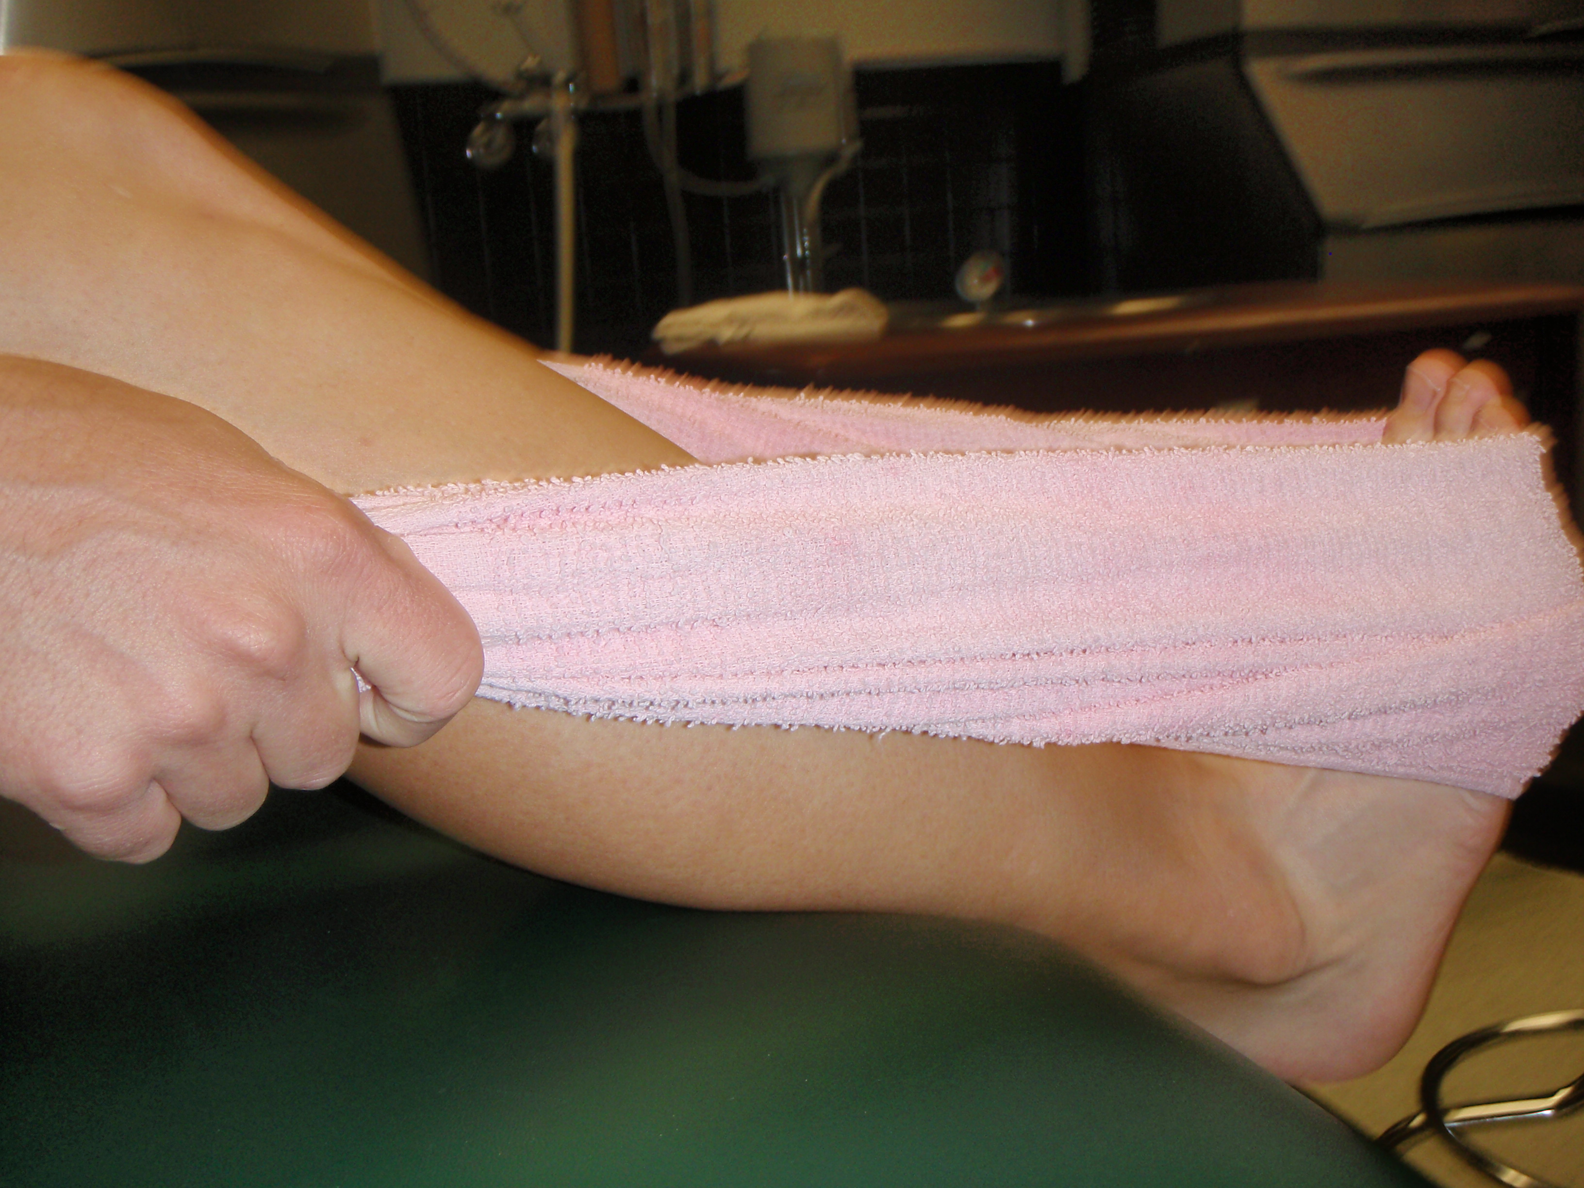

ABC’s
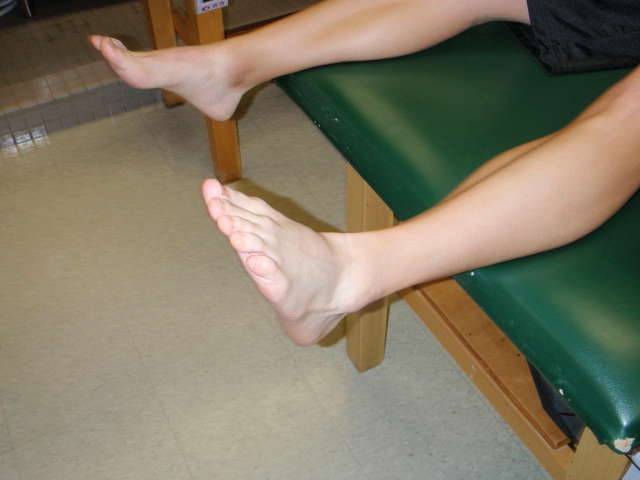
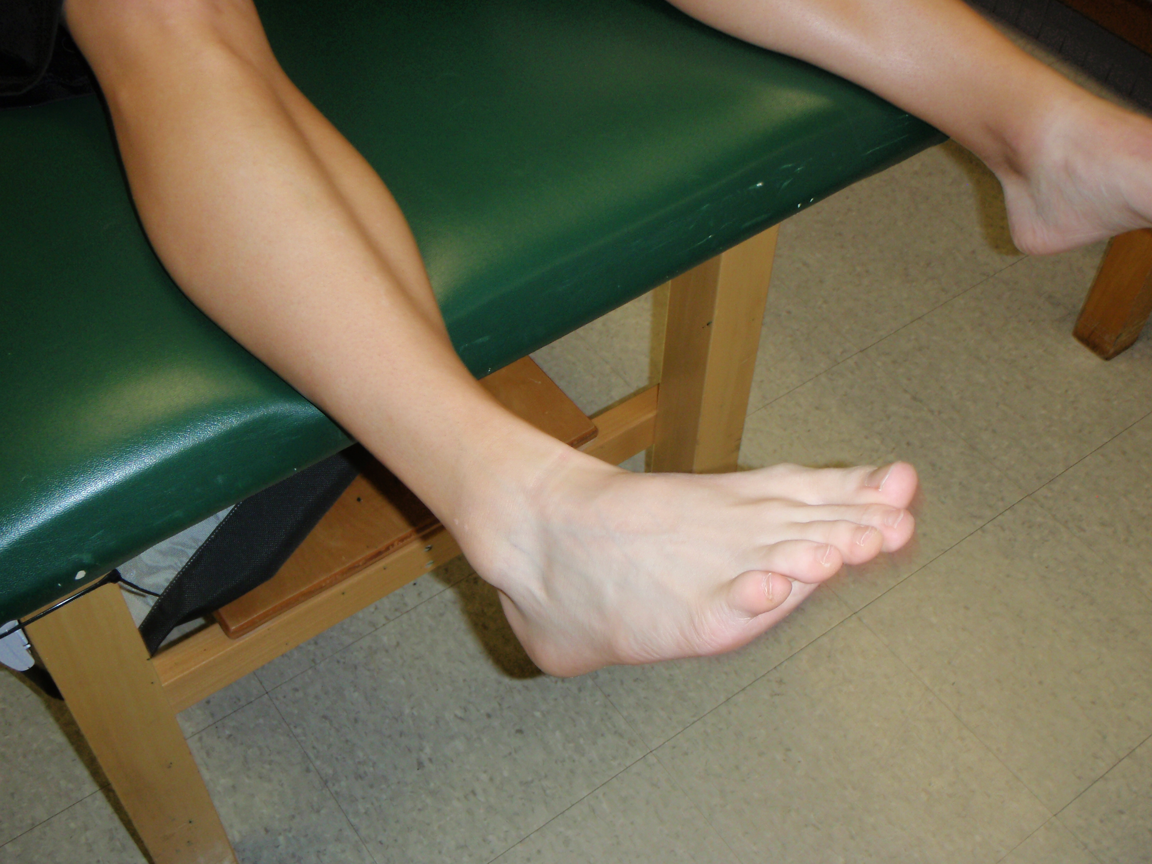

A

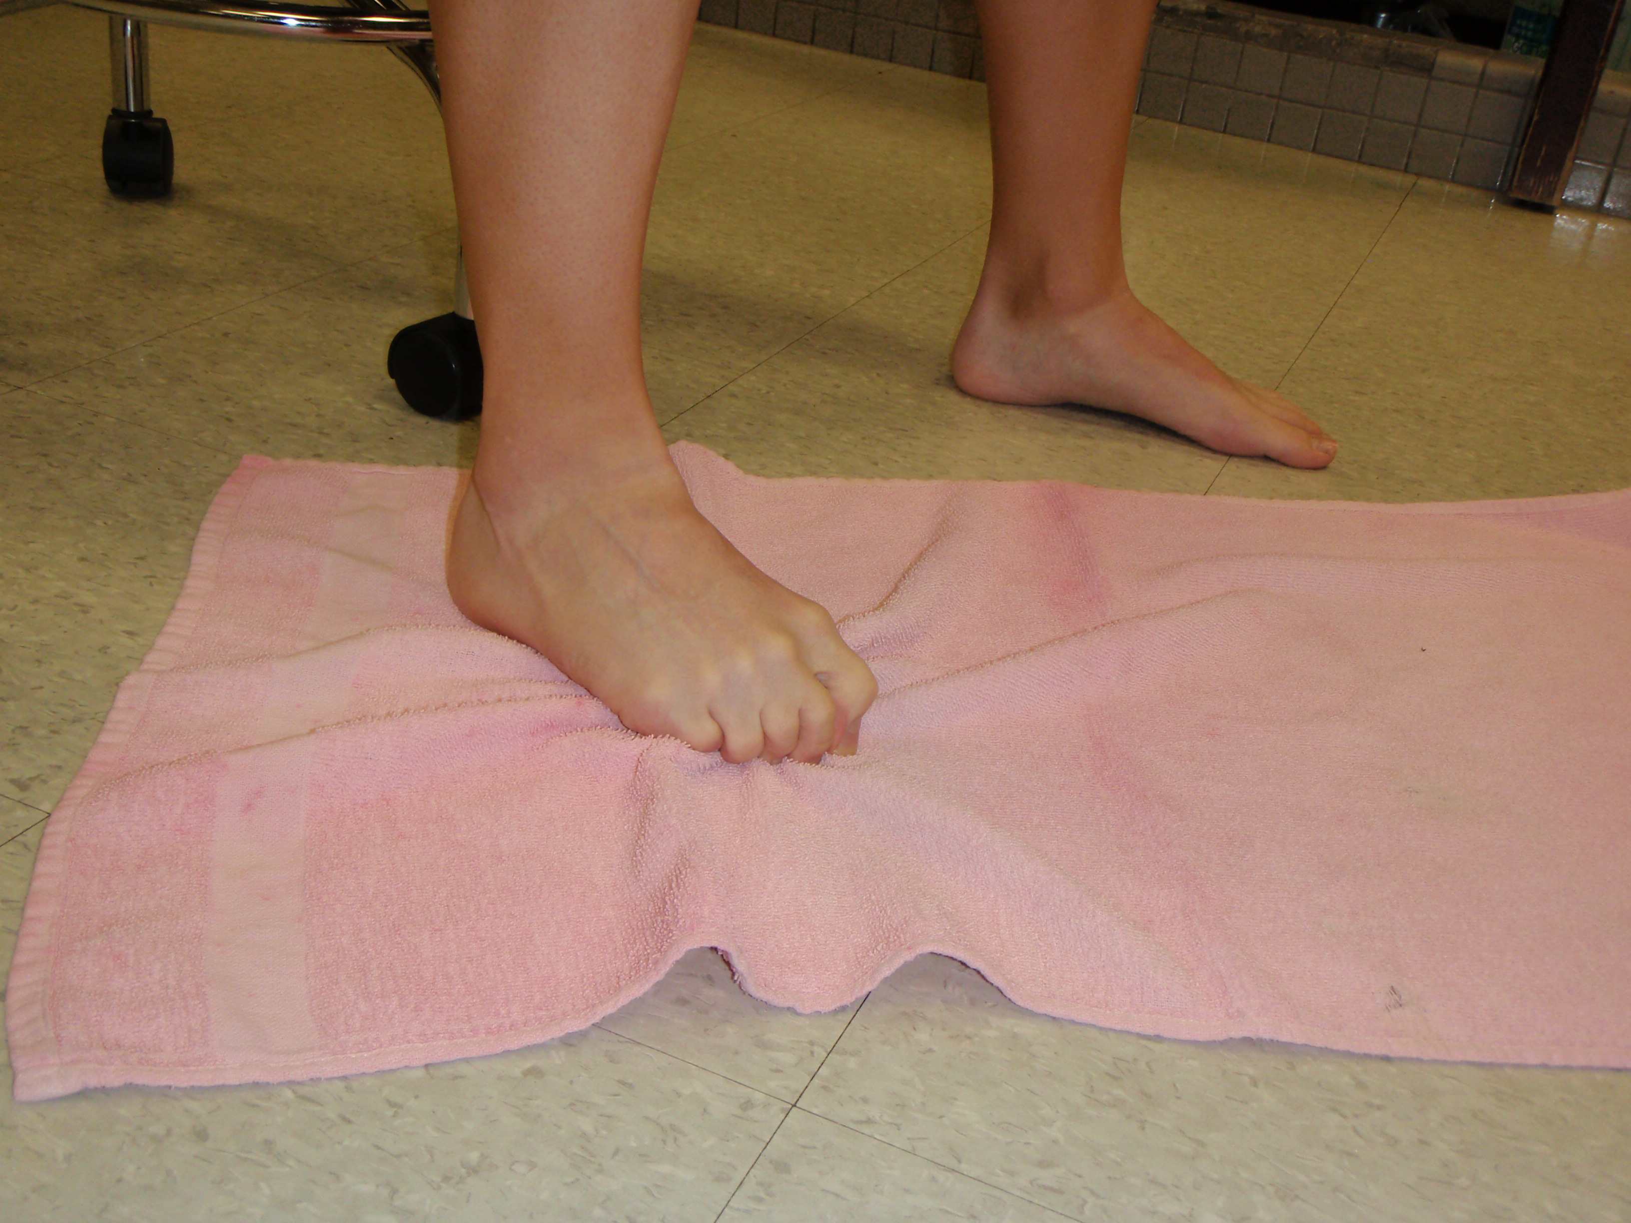
Towel Scrunches
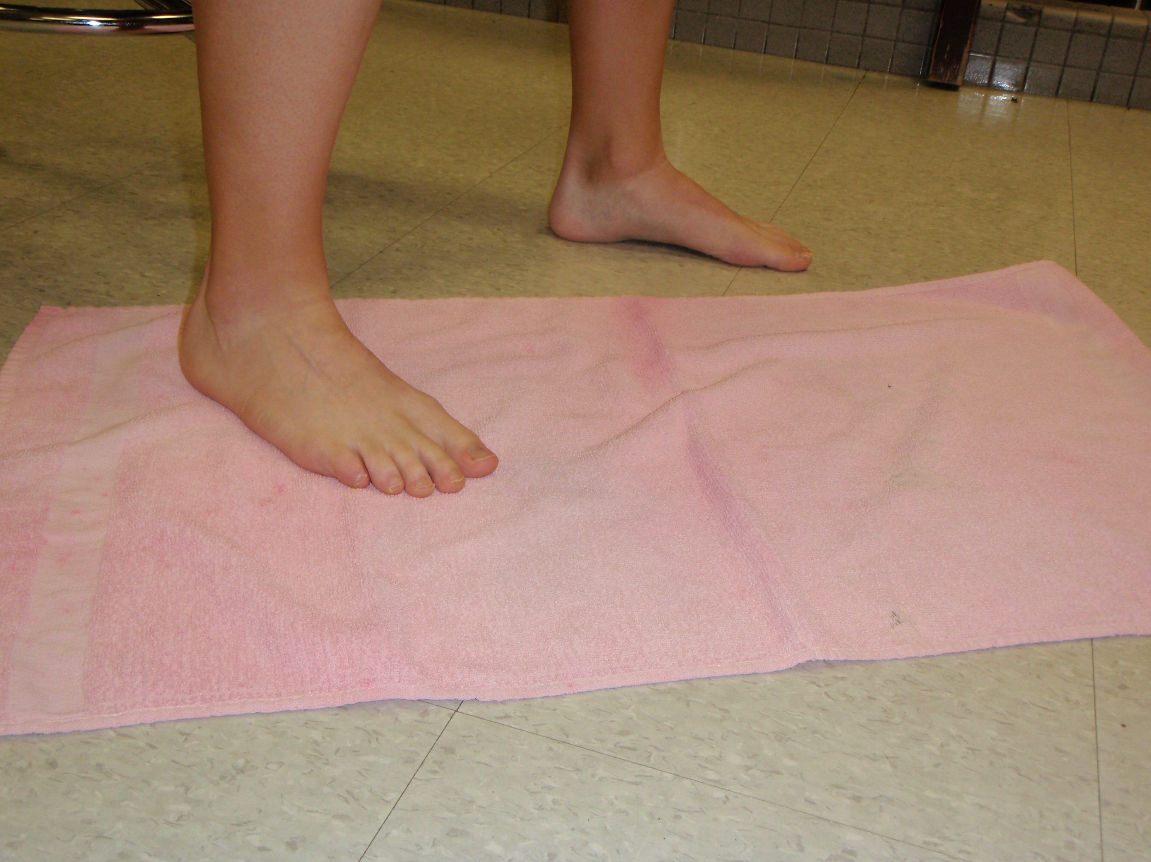

Seated heal raise
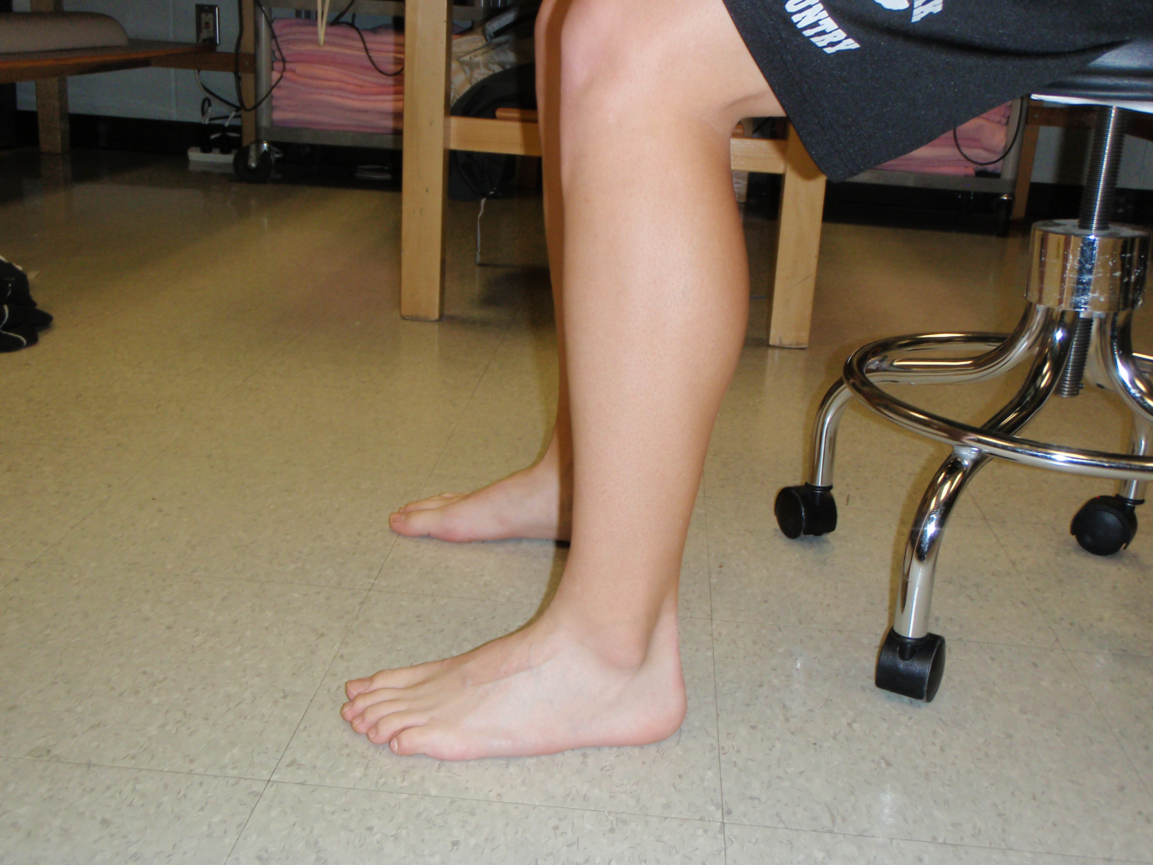
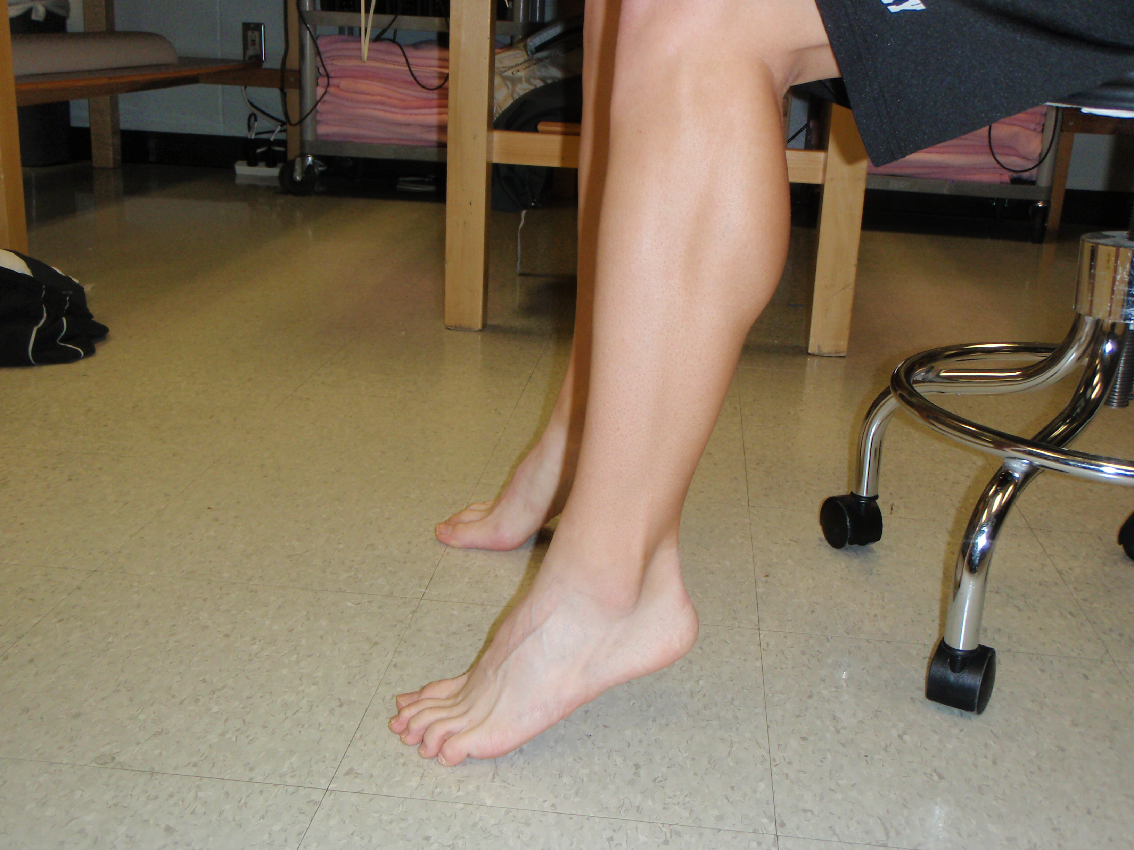

Athlete must have minimal to no swelling and an increase of ROM

Phase 2
Goal of Phase is to increase ROM and increase strength
Continue towel stretch
Marble or rock pick up
Ankle Strengthening - All directions
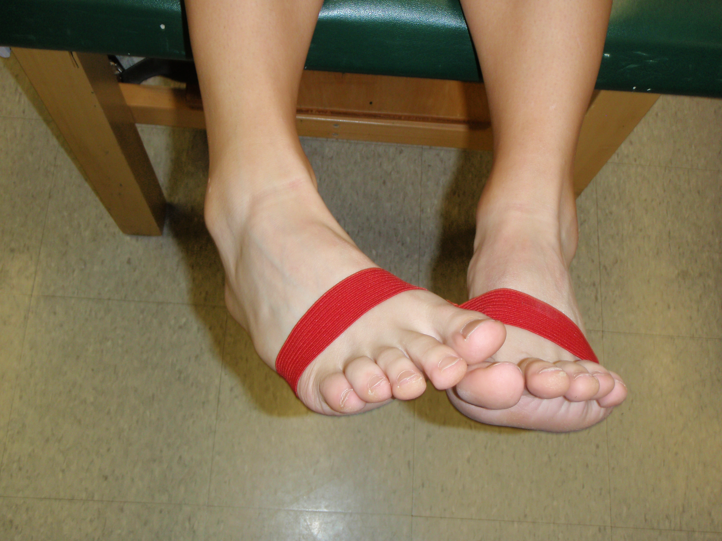
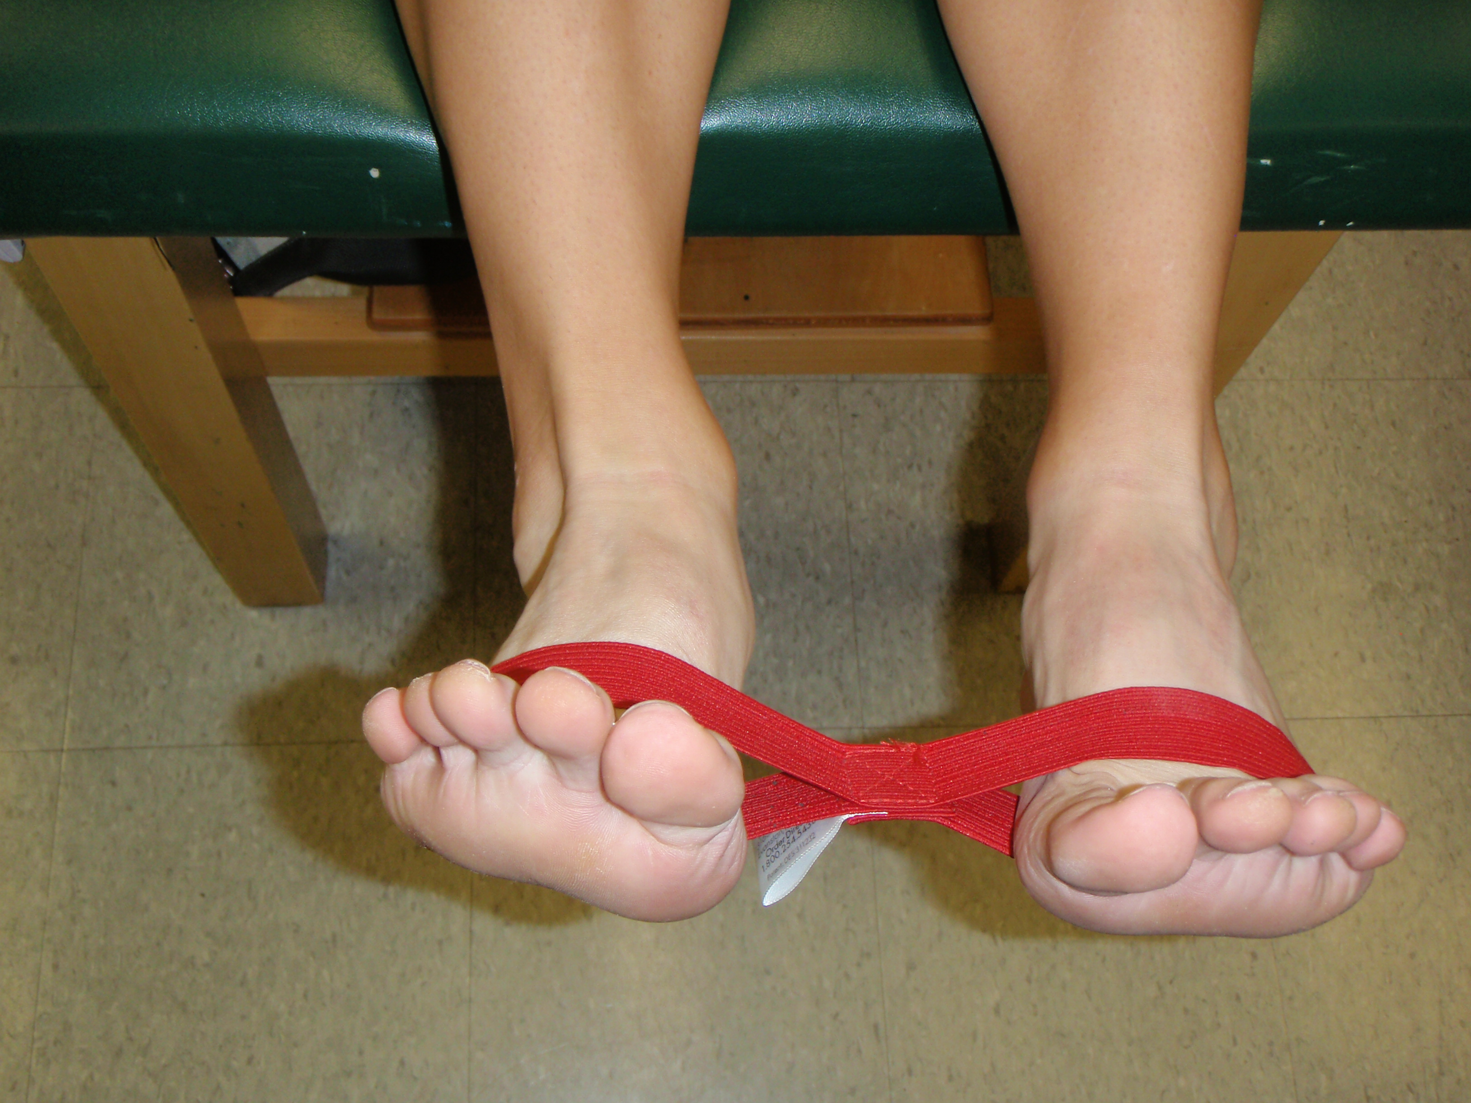

Eversion

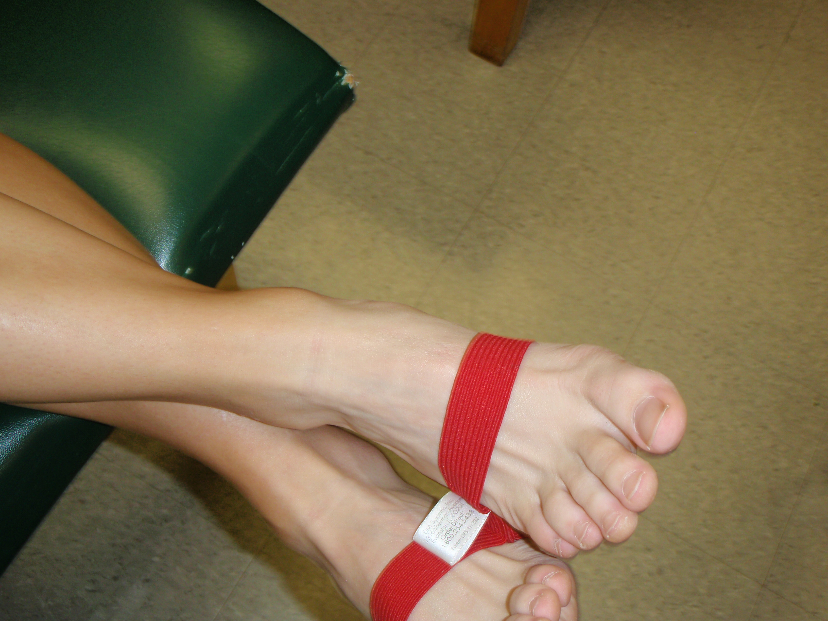
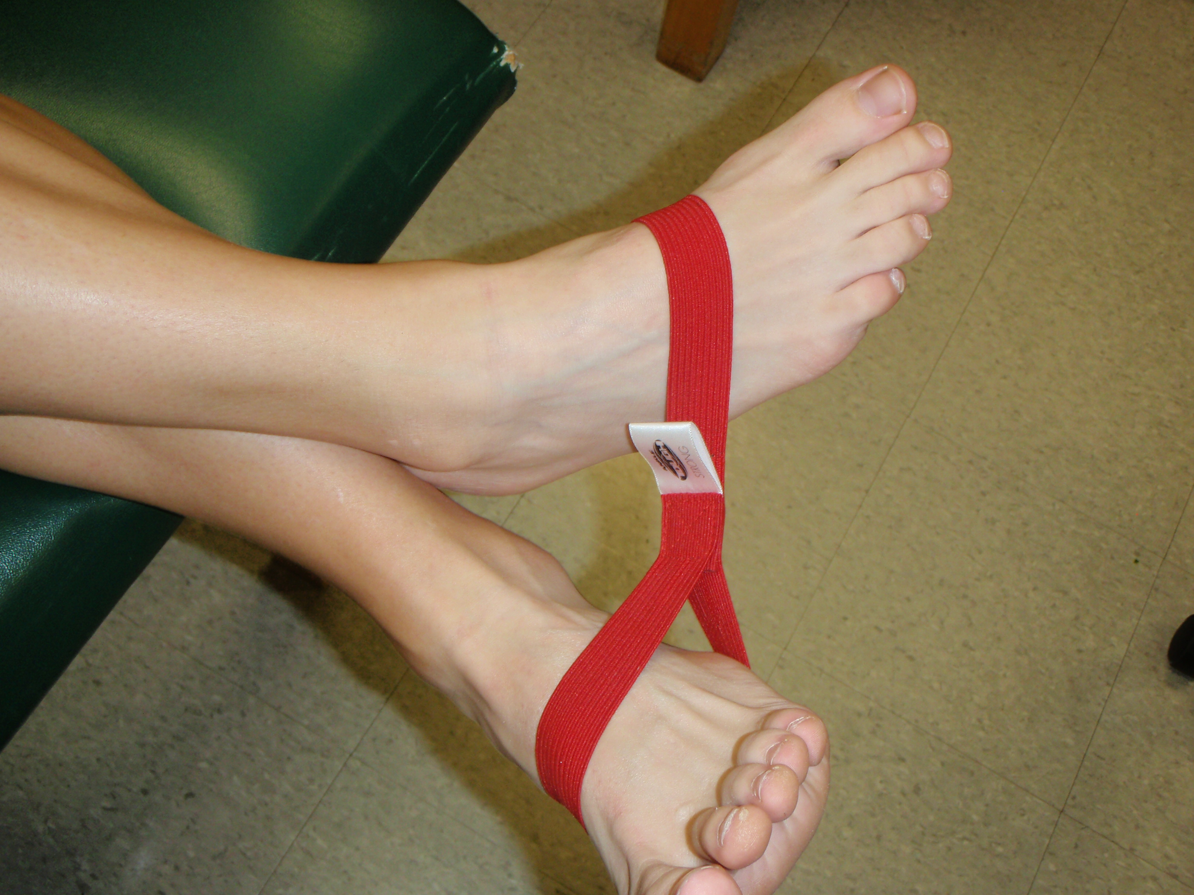

Inversion

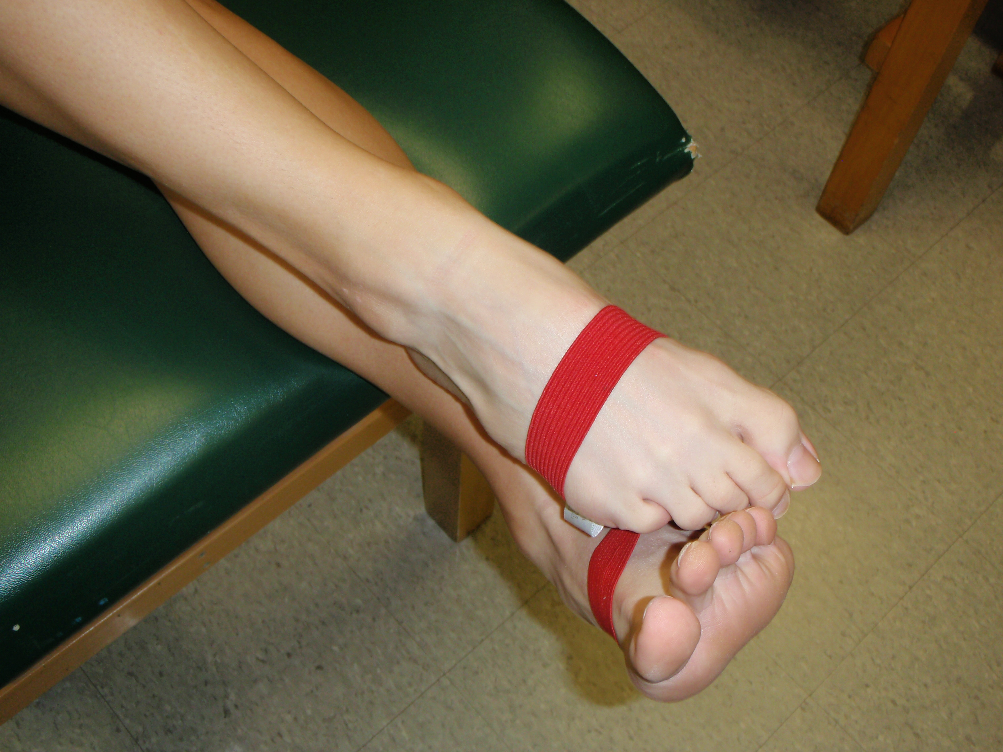
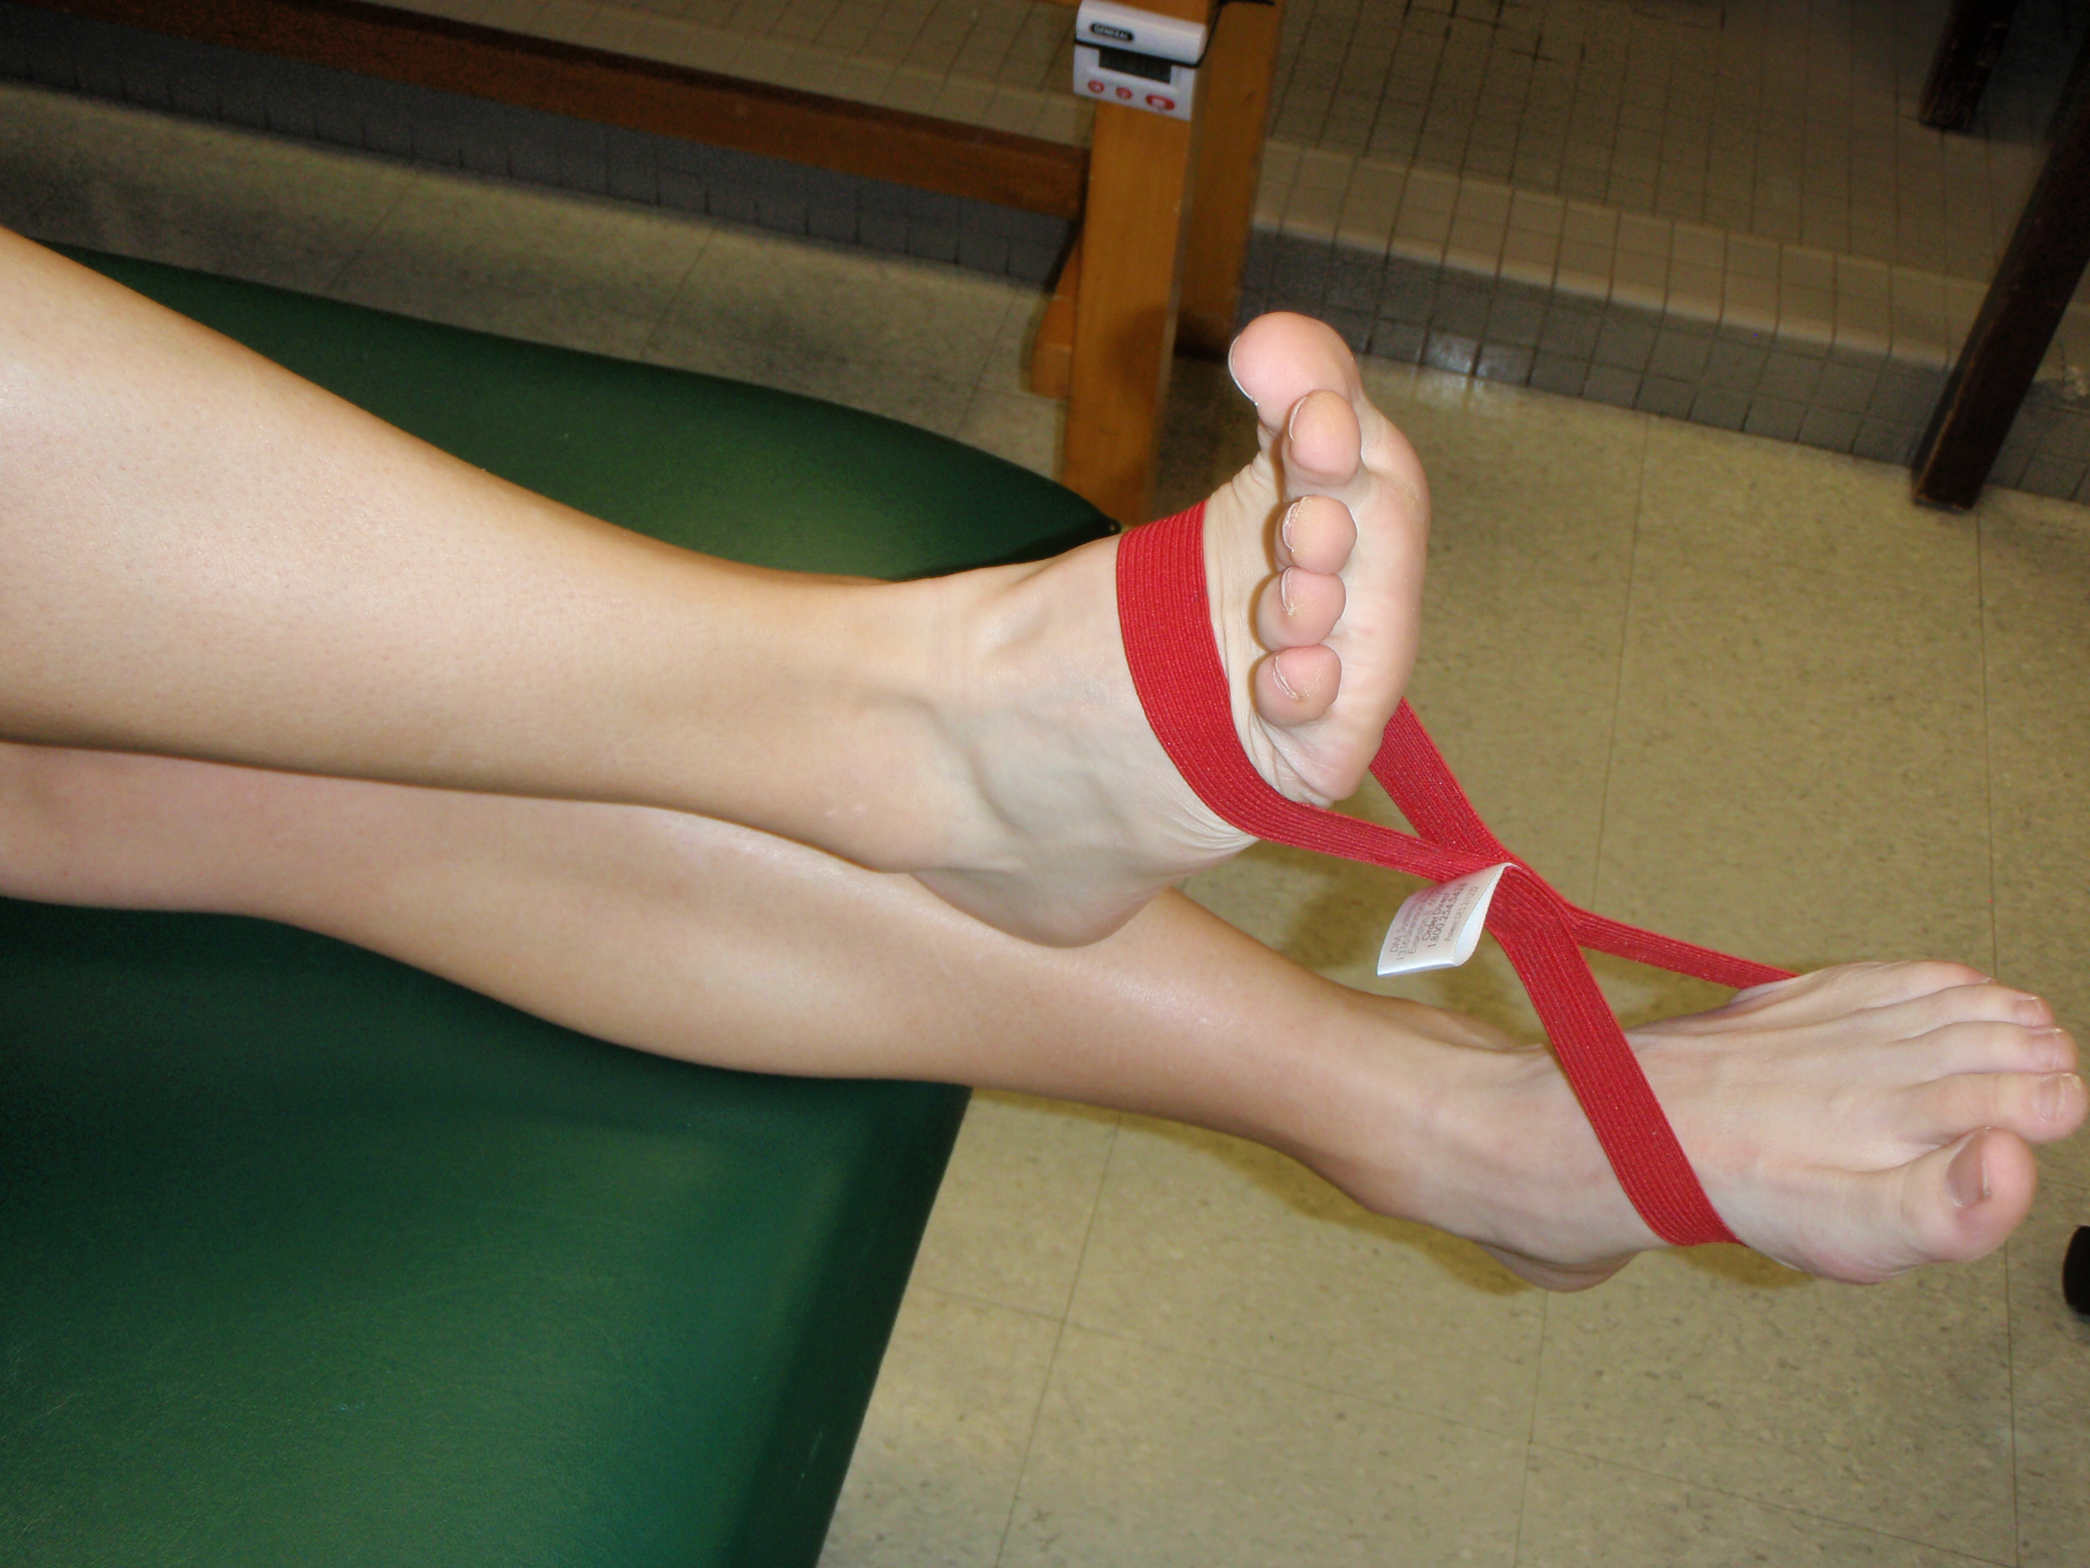

Dorsiflexion

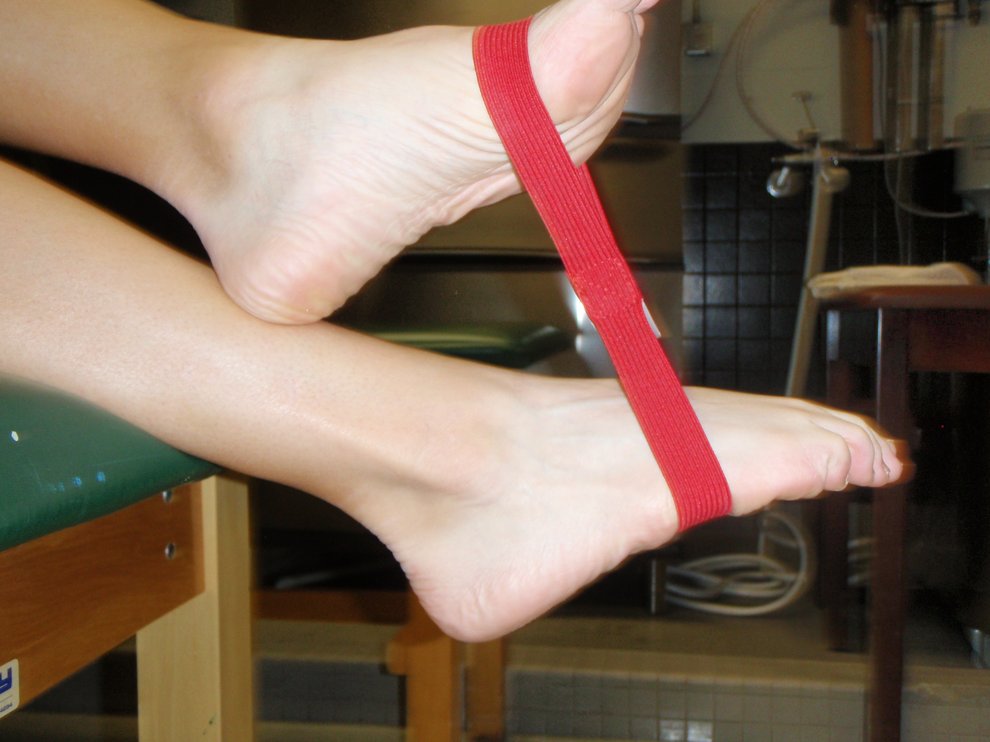
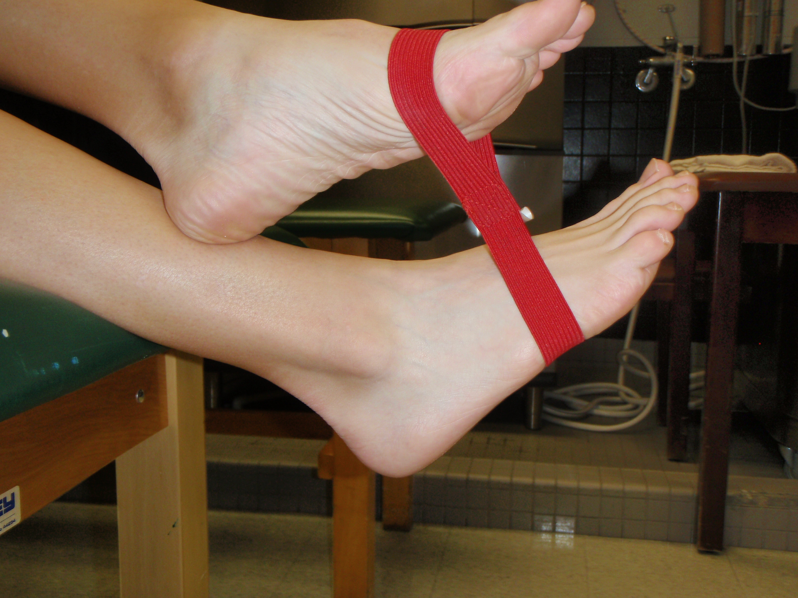

Plantarflexion

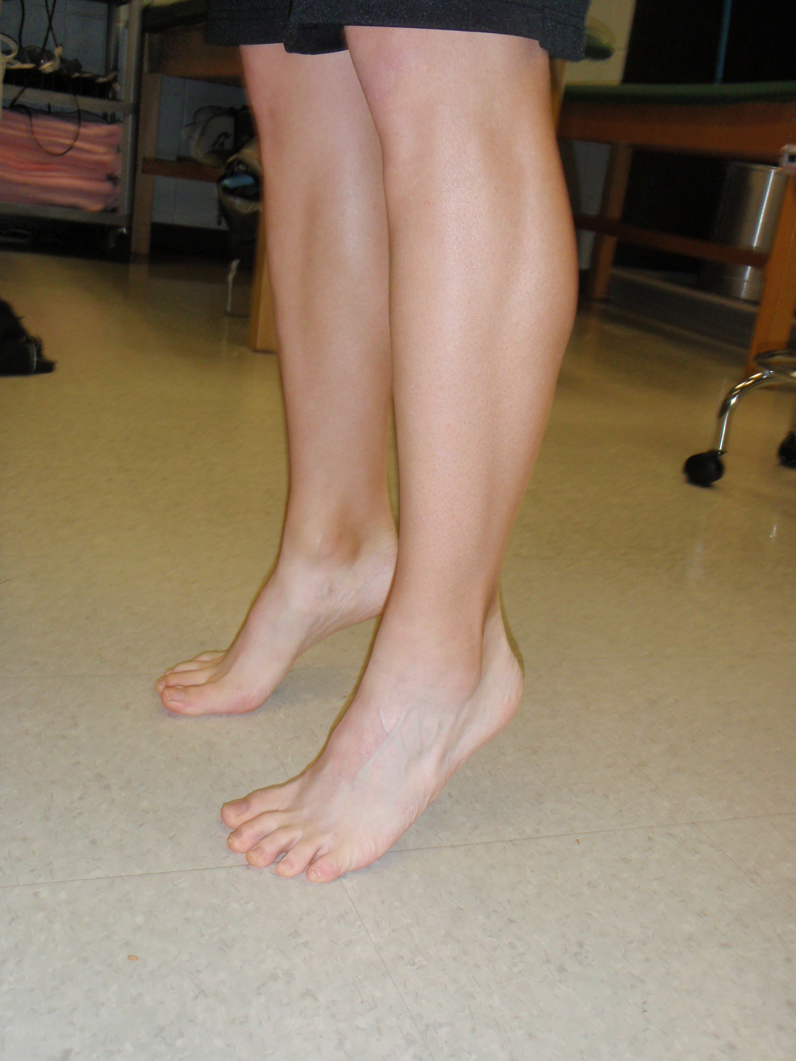
Heel Raises
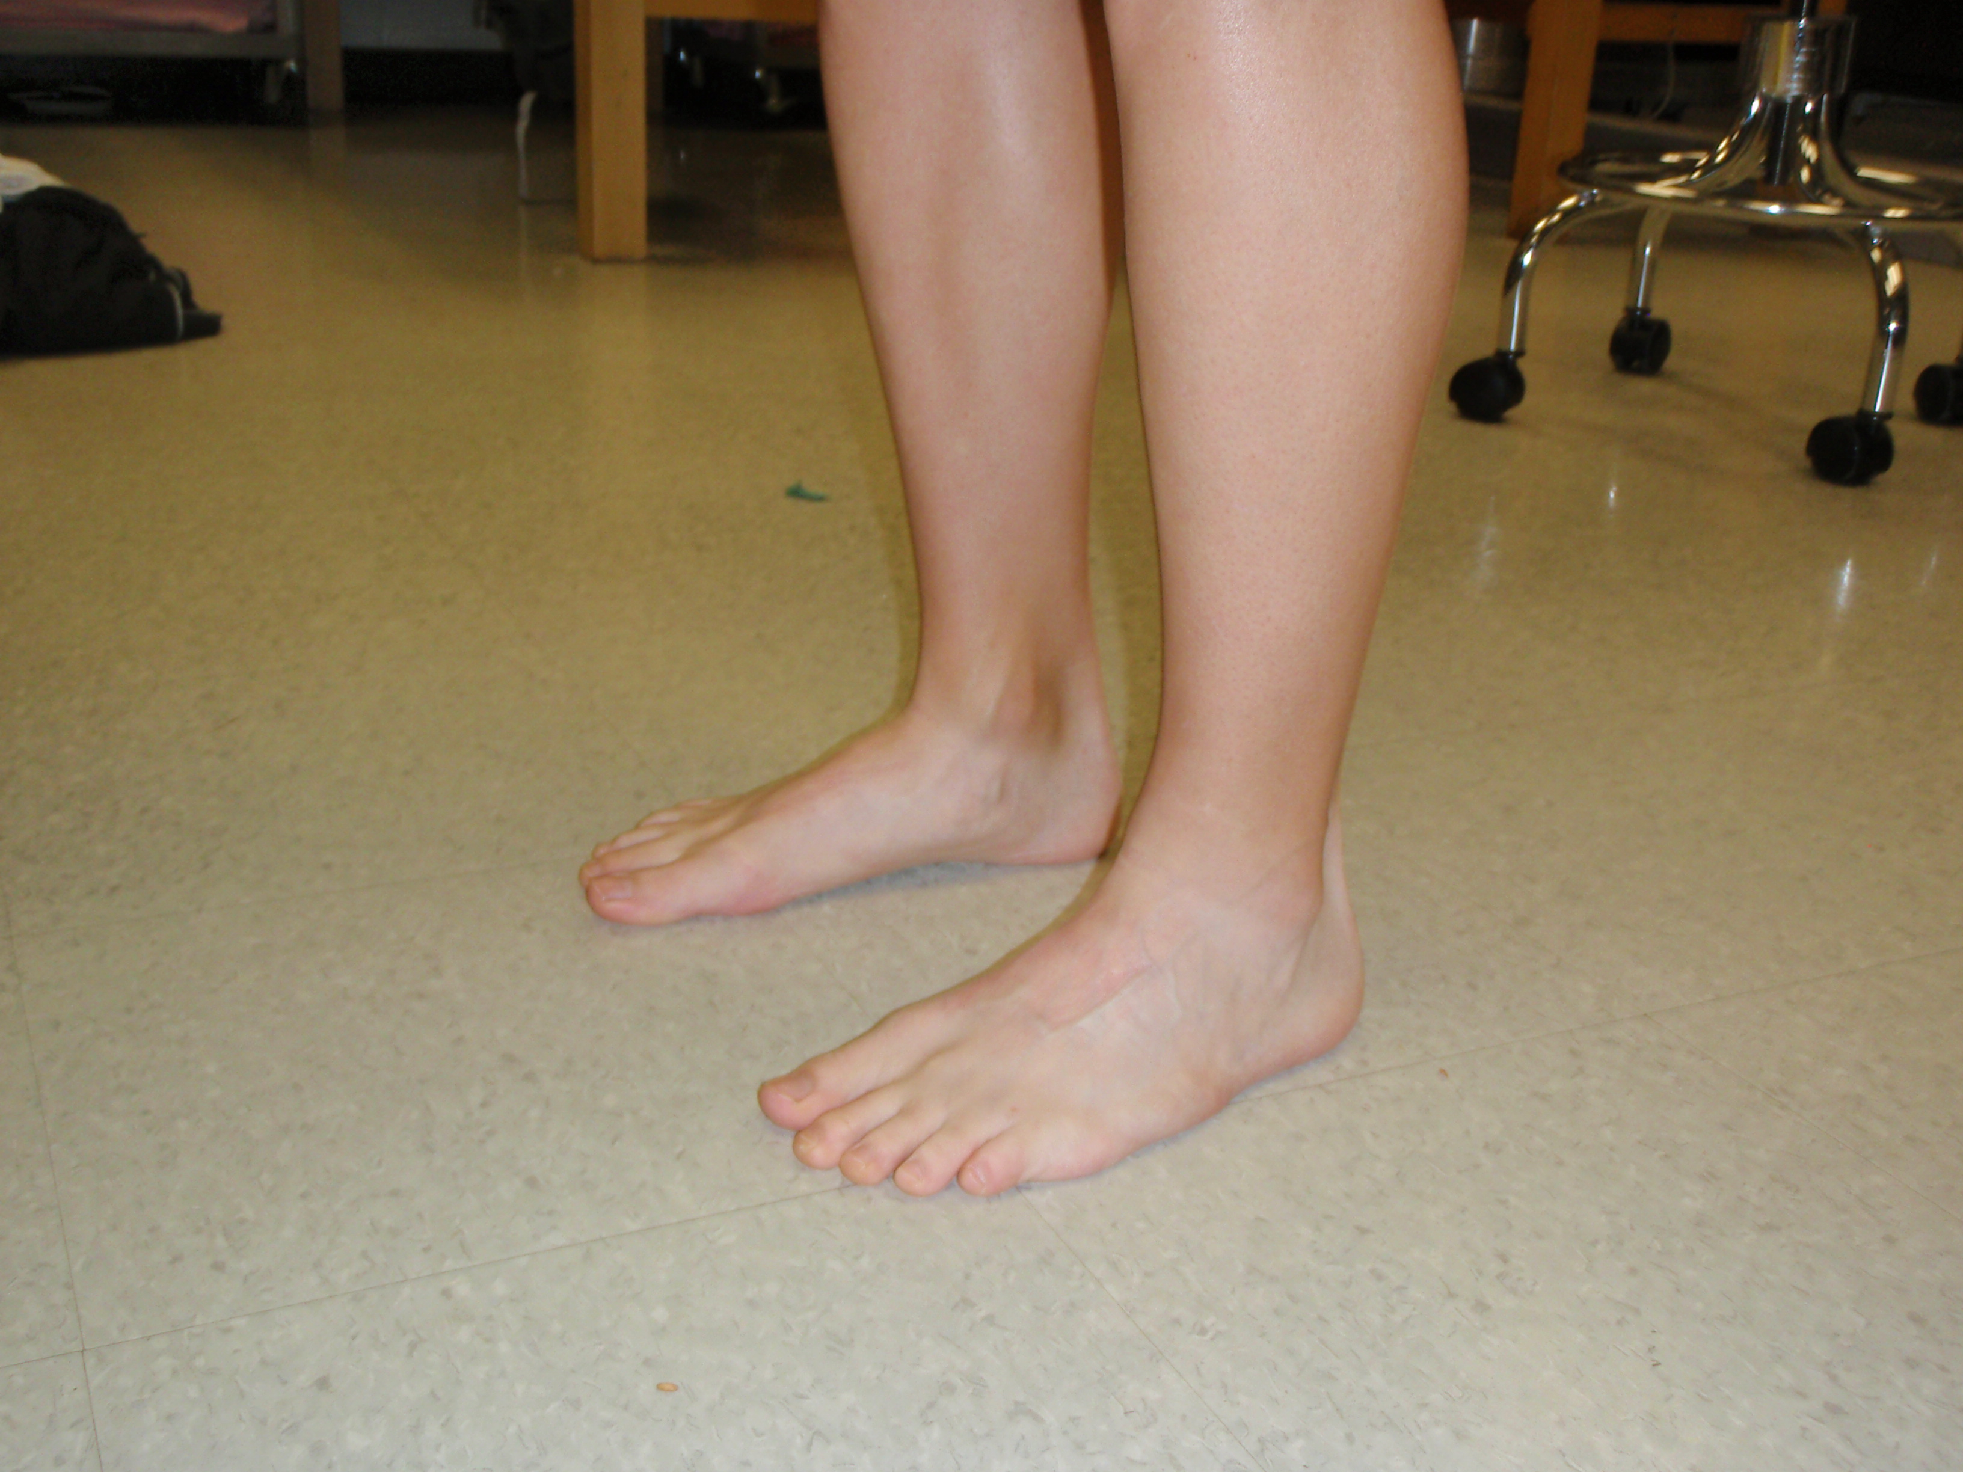

Toe Raises
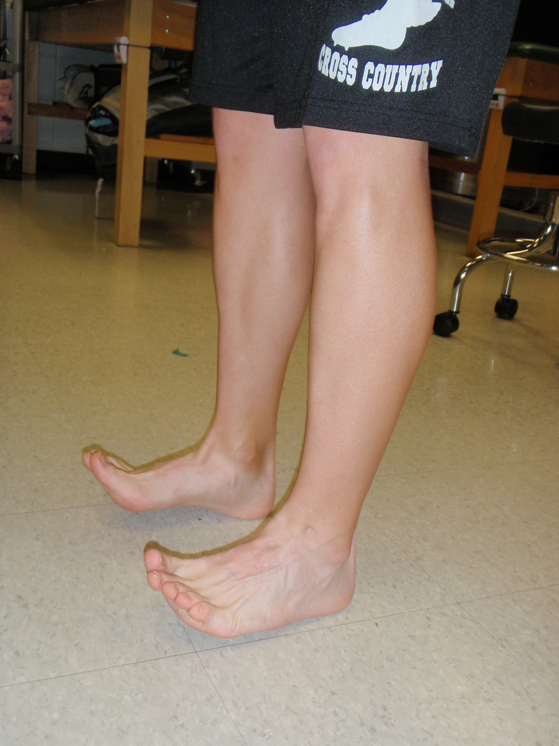

Balance (Stable)
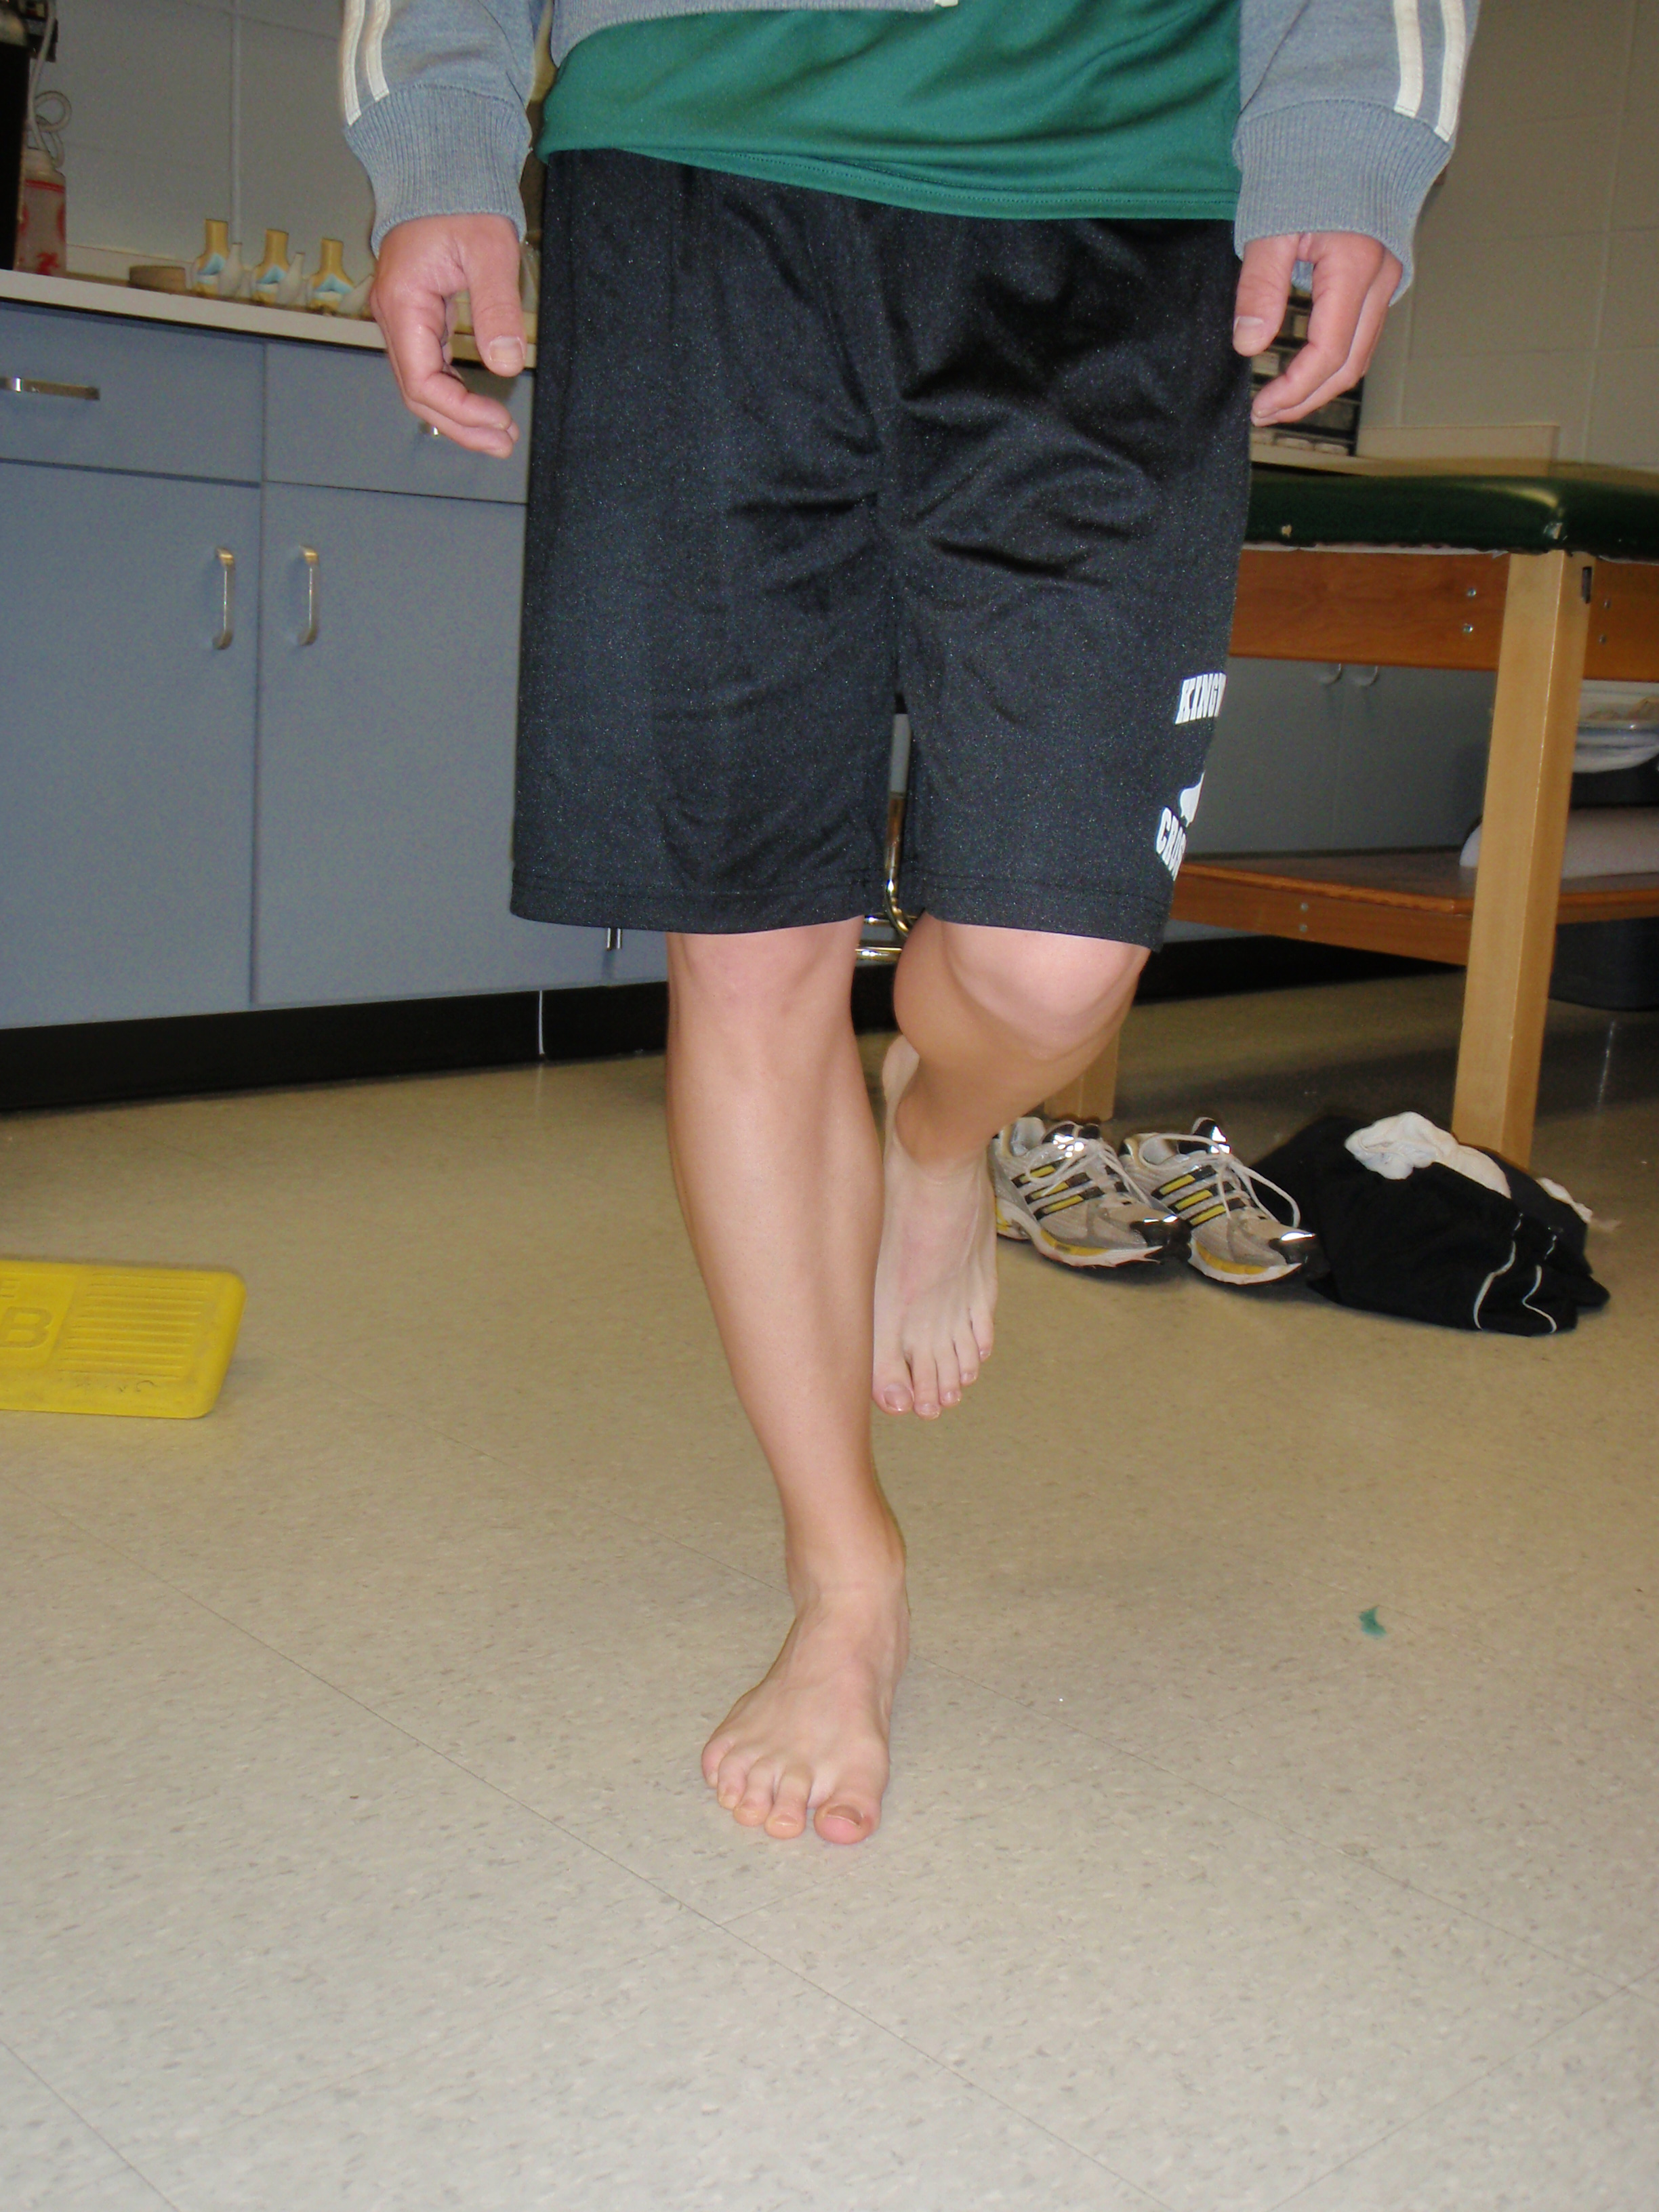

Cardio Machines
Athlete must have full ROM and 50% of strength to advance

Phase 3
Goal of Phase is to increase strength and proprioception
Increase difficulty of Ankle Tough Band
The Bob (Heel Raise)
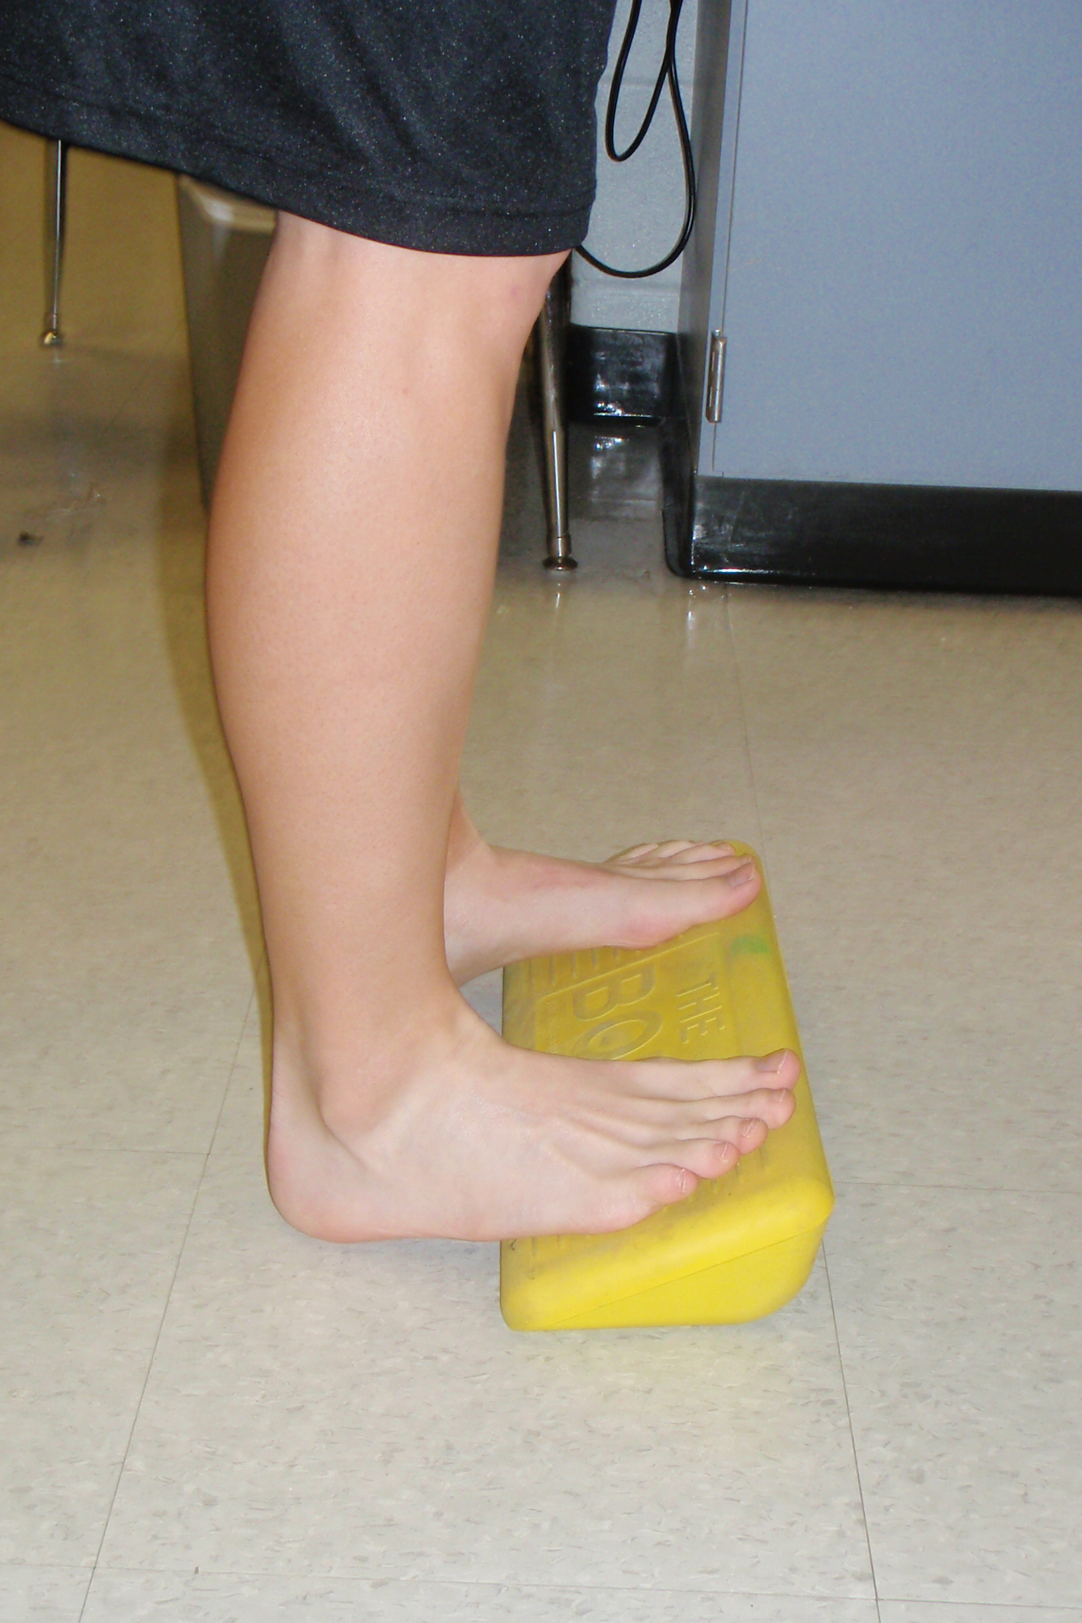
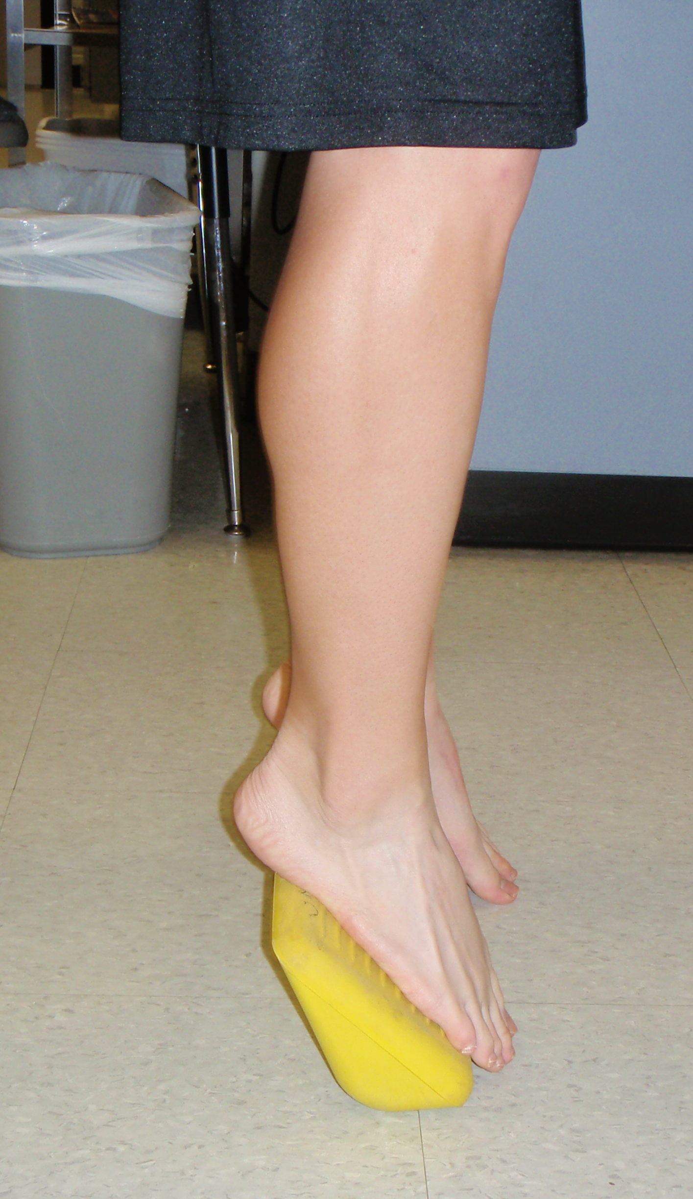

Balance (Unstable)
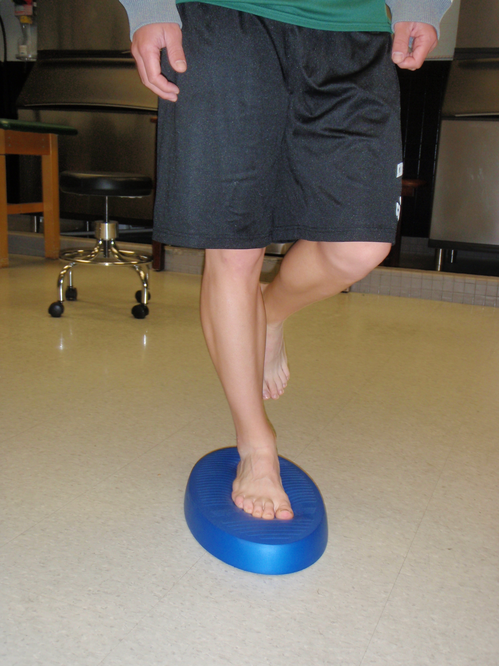

Cone touch (Stable then Unstable)
Lunge with unstable surface
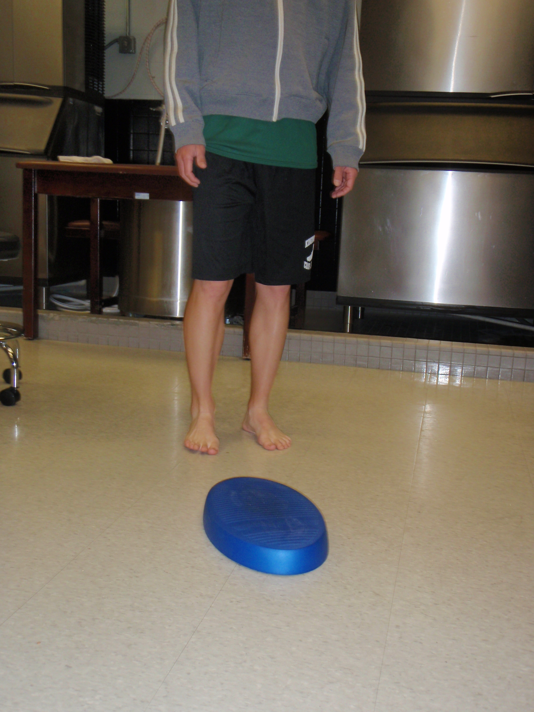
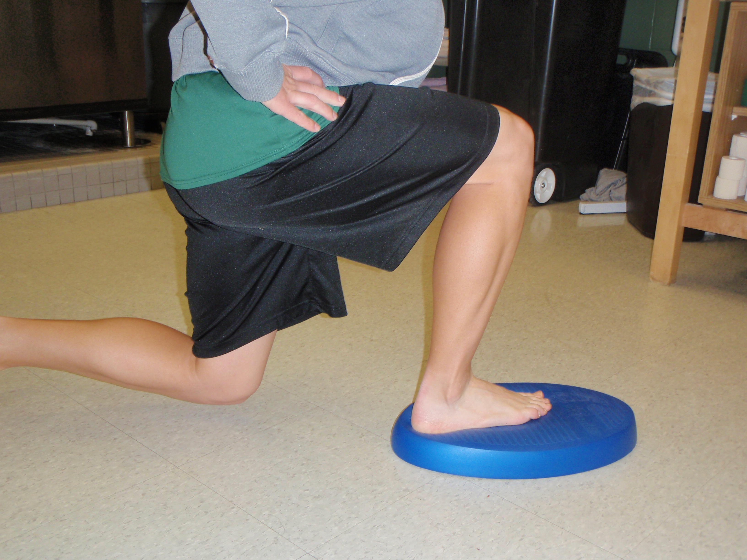

Cardio – Progress to Straight ahead running
Athlete must have full ROM and least 85% strength to advance

Functional Phase
Goal of Phase is to return to function and sport specific activity
All exercises with Phase 3 but increase in difficulty and reps
Bounding
Dot Jump
Zig-Zag Running
Plyo-jumps
Squat Jumps
Athlete must have normal movement patterns to be cleared

